
ULTRASONIC RADAR SYSTEM

PREPARED BY
YASMINE IBRAHIM 221007524
IBRAHIM AHMED TOUNY 221004678

PREPARED FOR
Eng. Ahmed Morsy

Project Objective
This project aims to develop a fully functional ultrasonic radar system enhanced with additional features to improve usability and performance. The system incorporates joystick-based angle control to allow precise directional scanning, as well as a buzzer alarm that is triggered when an object is detected within a predefined distance threshold. These added functionalities enhance both the interactivity and reliability of the system

Project Description
The ultrasonic radar system incorporates many features that include the main factors of data acquisition as well as the visual feedback, data collection and storage. The main function of the system highlights the combination of a servo motor (SG90) that rotates through 180 degrees and an ultrasonic sensor on top of it. System was built using two interconnected Arduinos, MEGA and UNO, MEGA is responsible for collecting data from sensors and control
(Ultrasonic and joystick module), UNO is responsible for controlling the actuators (servo motor and buzzer).
On the side of data collection and processing, Arduino MEGA sends collected data to a specific software (Processing IDE) using serial communication (UART) in order to be processed and displayed on a 180 degrees radar visualization, with clear distance and object detection display, the programming language used in Processing IDE is python, MEGA sends the data to UNO using UART protocol, for Arduino uno to start acting on the actuators based on the defined code in ARDUINO IDE.
For data collection and storage, Arduino Uno sends the data received from sensors and actuators to a python file in order to save it and log it in a n SQLite database. Data processing was done through both Arduinos to prevent COM PORT clashes.
The system has 2 modes , Manual and Auto , the default is manual , to switch between modes the joystick module must be pressed down to switch to the other mode , the Manual mode allows the joystick module to take control while the auto mode lets the servo motor rotate continuously over the 180 degrees.

Sensors used: Used IDE:
Ultrasonic sensor Processing
Visual studio code
User control by: Arduino
Joystick module SQLite
Proteus

Actuators used: Programming languages used:
Servo motor(SG90) Python
Buzzer C language

Hardware Components List

Servo Motor (SG90)
Sound Buzzer
Ultrasonic Sensor
Joystick Module
Arduino Uno
Arduino Mega
Jumpers
Breadboard

Design
The system is designed to detect distances up to 100m , buzzer is thrown off when any object is detected within 30 meters of the diameter of the ultrasonic sensor , angle is increased 10 degrees at a time on both manual and automatic mode

Circuit Diagram

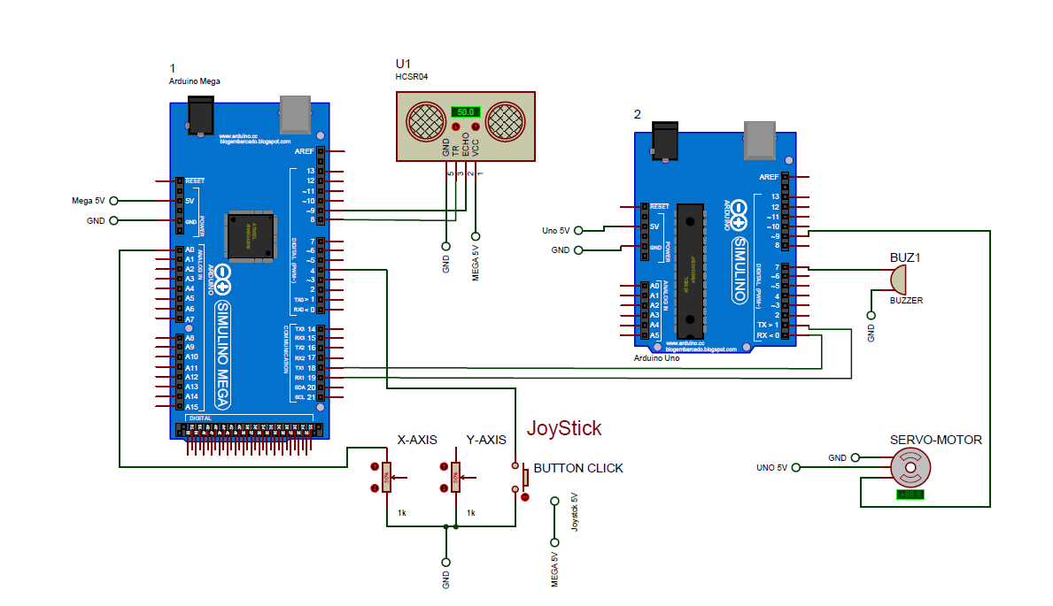

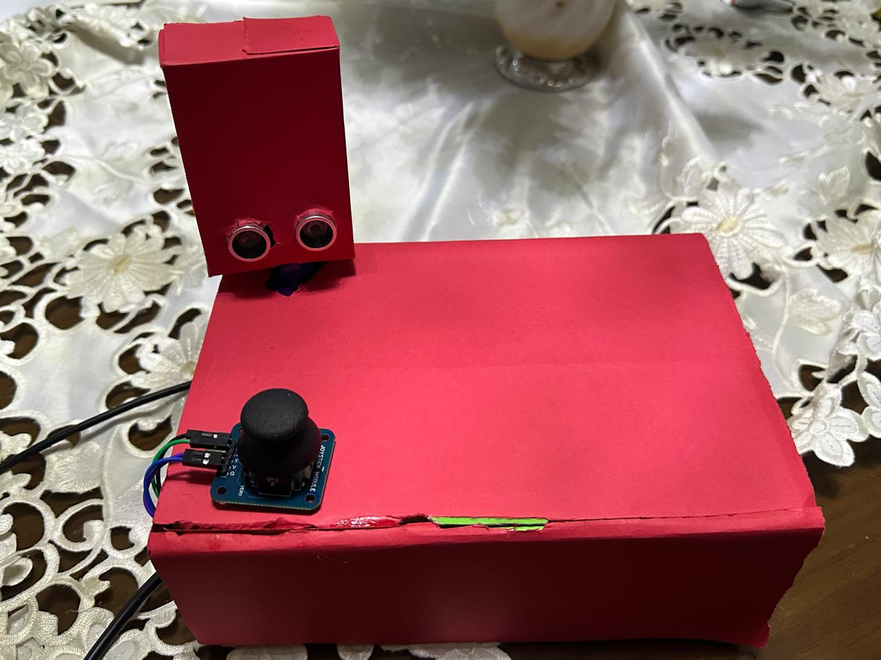

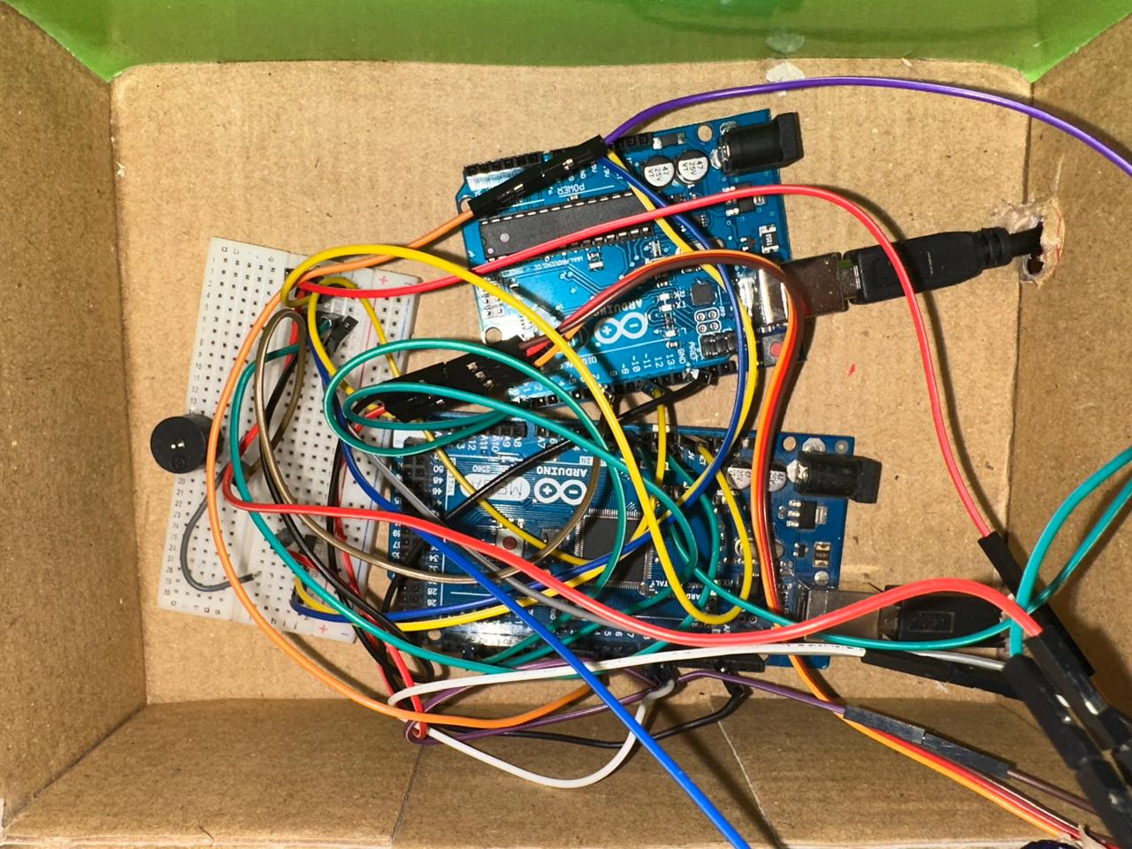

Connection procedure
- Common ground between 2 Arduinos
- RX1 in Arduino Mega connected to TX in Arduino Uno
- TX1 in Arduino Mega connected to RX in Arduino Uno
- Ultrasonic Sensor (HC-SR04):
  - +VE pin to the Arduino Mega 5V
  - -VE pin to the GND
  - Echo pin to Pin 8 in the Arduino Mega
  - Trig pin to Pin 9 in the Arduino Mega
- Joystick Module:
  - +VE pin to the Arduino Mega 5V
  - -VE pin to GND
  - X-axis pin to pin A0 in the Arduino Mega
  - SW pin to Pin 4 in the Arduino Mega
  - Y-axis not connected
- Servo Motor (SG-90):
  - +VE pin to the Arduino Uno 5V
  - -VE pin to the GND
  - Control pin to Pin 9 in the Arduino Uno
- Buzzer:
  - +VE pin connected to Pin 7 in the Arduino Uno
  - -VE pin connected to GND

Database
Data storage is a crucial part of data acquisition systems. Our ultrasonic system stores the data collected from all sensors, it has real time data logging of all system operations , as will as histrorical tracking of objects, distance , and mode the system is operating in, which helps in debugging and performance monitoring overtime
Table: radar_logs

Database Schema:

- **id**: INTEGER PRIMARY KEY AUTOINCREMENT - Unique identifier for each log entry
- **timestamp**: TEXT - Date and time of the reading (ISO format)
- **angle**: INTEGER - Servo angle position (15° to 165°)
- **distance**: INTEGER - Object distance in centimeters (from ultrasonic sensor)
- **mode**: INTEGER - Operation mode (0 = Automatic, 1 = Manual)
- **buzzer_active**: INTEGER - Buzzer status (0 = Off, 1 = On when distance < 30cm)
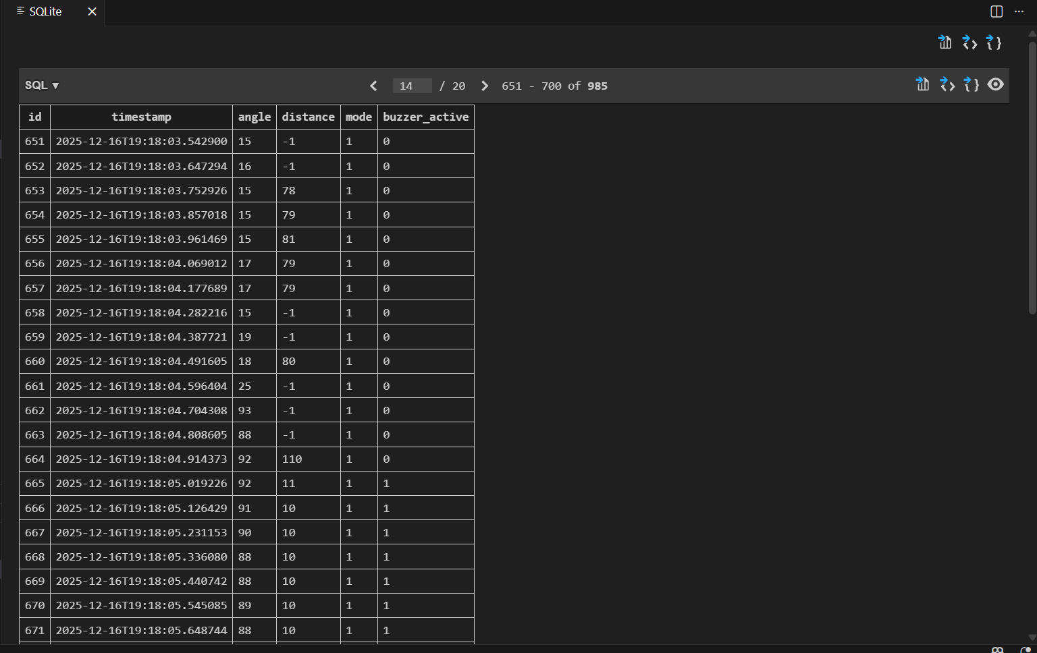

GUI/Dashboard
The Processing-based graphical user interface (GUI) visualizes real-time data from the ultrasonic radar system transmitted over a serial connection. Its primary purpose is to display the scanning angle, detected object distance, and radar sweep in an intuitive, radar-like format.
The GUI listens on COM6 at 9600 baud for incoming serial data from the Arduino uno. Each data packet is expected in the format of (angle, distance). The code parses this stream, extracts the angle and distance, and constrains the distance to a maximum of 100 cm to match the radar’s display scale. A distance value of -1 is treated as no echo / no object detected.
The radar is rendered as a semi-circular (180°) scan, centered at the bottom of the window with Five concentric arcs that represent distance intervals (each corresponding to 20 cm). Radial lines every 30° provide angular reference, mimicking a real radar scope.
A bright green rotating line represents the current ultrasonic sensor direction. Its rotation angle directly corresponds to the received angle value, giving a live visualization of the servo or joystick controlled scan
When an object is detected within range, a red line is drawn from the detected point outward, indicating the object’s position along the current angle. If no echo is detected, the GUI uses an orange color to indicate the absence of a valid reflection. The detected distance is mapped proportionally to the radar radius to ensure accurate representation.
A lower information bar displays some information that may be useful to the inspector such as the current angle (degrees), Measured distance (cm) or -- if no object is detected, Range status (“In Range” or “Out of Range”), Distance labels (20 cm increments) are shown along the radar arc .Names are displayed for project identification.
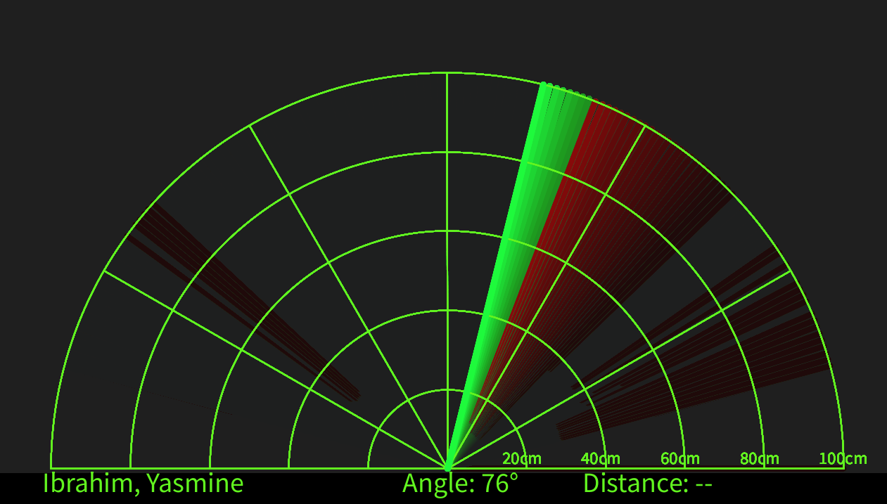

Code
#Arduino Mega
const int trigPin = 8;
const int echoPin = 9;

const int joyX = A0;
const int joySW = 4;

int angle = 90;
int dir = 1;
bool manualMode = false;
bool lastSW = HIGH;

long duration;
int distance;

// to fix manual mode
unsigned long lastManualSend = 0;
const unsigned long MANUAL_INTERVAL = 20; // 20 ms = servo-safe

int calculateDistance() {
digitalWrite(trigPin, LOW);
delayMicroseconds(2);
digitalWrite(trigPin, HIGH);
delayMicroseconds(10);
digitalWrite(trigPin, LOW)
duration = pulseIn(echoPin, HIGH, 25000);
if (duration == 0) return -1;
return duration * 0.034 / 2;
}

void setup() {
pinMode(trigPin, OUTPUT);
pinMode(echoPin, INPUT);
pinMode(joySW, INPUT_PULLUP);

Serial.begin(9600); // → Processing
Serial1.begin(115200); // → Arduino UNO
}

void loop() {

bool sw = digitalRead(joySW);
if (lastSW == HIGH && sw == LOW) {
manualMode = !manualMode;
delay(200);
}
lastSW = sw;

if (manualMode) {
int x = analogRead(joyX);
angle = map(x, 0, 1023, 15, 165);
} else {
angle += dir;
if (angle >= 165 || angle <= 15) dir = -dir;
}

distance = calculateDistance();

// → Processing
Serial.print(angle);
Serial.print(",");
Serial.print(distance);
Serial.print(".");

if (!manualMode) {
// AUTO mode → same behavior as before
Serial1.print(angle);
Serial1.print(",");
Serial1.print(distance);
Serial1.print(",");
Serial1.print("0"); // AUTO = 0
Serial1.print(".");
delay(30); // unchanged AUTO speed
}
else {
// MANUAL mode → rate limited
unsigned long now = millis();
if (now - lastManualSend >= MANUAL_INTERVAL) {
lastManualSend = now;

Serial1.print(angle);
Serial1.print(",");
Serial1.print(distance);
Serial1.print(",");
Serial1.print("1"); // MANUAL = 1
Serial1.print(".");
}
}

if(!manualMode)
delay(30);
}

#Arduino Uno
#include <Servo.h>

#define SERVO_PIN 10
#define BUZZER_PIN 7

Servo myServo;
#define BUF_SIZE 32
char rxBuffer[BUF_SIZE];
byte rxIndex = 0;
int angle = 90;
int distance = -1;
int mode = 0; // 0 = AUTO, 1 = MANUAL

void setup() {
Serial.begin(115200); // UART from Mega
myServo.attach(SERVO_PIN);
pinMode(BUZZER_PIN, OUTPUT);
}

void loop() {
readSerial();
}

void readSerial() {
while (Serial.available()) {
char c = Serial.read();

if (c == '.') {
rxBuffer[rxIndex] = '\0';
parsePacket(rxBuffer);
rxIndex = 0; // reset buffer
}
else {
if (rxIndex < BUF_SIZE - 1) {
rxBuffer[rxIndex++] = c;
} else {
// buffer overflow → reset safely
rxIndex = 0;
}
}
}
}

void parsePacket(char *packet) {

char *comma1 = strchr(packet, ',');
if (!comma1) return;

*comma1 = '\0';

char *comma2 = strchr(comma1 + 1, ',');
if (!comma2) return;

*comma2 = '\0';

int newAngle = atoi(packet);
int newDistance = atoi(comma1 + 1);
int newMode = atoi(comma2 + 1);
if (newAngle < 15 || newAngle > 165) return;
angle = newAngle;
distance = newDistance;
mode = newMode;

myServo.write(angle);

bool buzzerActive = false;
if (distance > 0 && distance < 30) {
tone(BUZZER_PIN, 2000);
buzzerActive = true;
} else {
noTone(BUZZER_PIN);
buzzerActive = false;
}
Serial.print(angle);
Serial.print(",");
Serial.print(distance);
Serial.print(",");
Serial.print(mode);
Serial.print(",");
Serial.print(buzzerActive ? 1 : 0);
Serial.println();
}

# Processing
import processing.serial.*;
import java.awt.event.KeyEvent;
import java.io.IOException;

Serial myPort;

String distance = "";
String data = "";
String noObject;
String angle = "";

float pixsDistance;
int iAngle, iDistance;
int index1 = 0;

float radarRadius;

void setup() {

size(1280, 720);
smooth();

radarRadius = width * 0.44;

myPort = new Serial(this, "COM6", 9600);
myPort.bufferUntil('.');
}

void draw() {

noStroke();
fill(0, 4);
rect(0, 0, width, height - height * 0.065);

fill(98, 245, 31);
drawRadar();
drawLine();
drawObject();
drawText();
}

void serialEvent(Serial myPort) {

data = myPort.readStringUntil('.');
data = data.substring(0, data.length() - 1);

index1 = data.indexOf(',');

angle = data.substring(0, index1);
distance = data.substring(index1 + 1);

iAngle = int(angle);
iDistance = min(int(distance), 100);
}

void drawRadar() {

pushMatrix();
translate(width / 2, height - height * 0.074);
noFill();
strokeWeight(2);
stroke(98, 245, 31);

for (int i = 1; i <= 5; i++) {
float r = radarRadius * i / 5.0;
arc(0, 0, r * 2, r * 2, PI, TWO_PI);
}

for (int a = 0; a <= 180; a += 30) {
line(0, 0,
radarRadius * cos(radians(a)),
-radarRadius * sin(radians(a)));
}

popMatrix();
}

void drawObject() {

pushMatrix();
translate(width / 2, height - height * 0.074);
strokeWeight(9);

if (iDistance == -1) {
stroke(255, 165, 0); // ORANGE → no echo
} else {
stroke(255, 10, 10); // RED → valid object
}

pixsDistance = map(constrain(iDistance, 0, 100), 0, 100, 0, radarRadius);

if (iDistance < 100 && iDistance != -1) {
line(
pixsDistance * cos(radians(iAngle)),
-pixsDistance * sin(radians(iAngle)),
radarRadius * cos(radians(iAngle)),
-radarRadius * sin(radians(iAngle))
);
}
popMatrix();
}

void drawLine() {
pushMatrix();
translate(width / 2, height - height * 0.074);
strokeWeight(9);
stroke(30, 250, 60);
line(0, 0,
radarRadius * cos(radians(iAngle)),
-radarRadius * sin(radians(iAngle)));
popMatrix();
}

void drawText() {

pushMatrix();

noObject = (iDistance == -1 || iDistance >= 100) ? "Out of Range" : "In Range";
fill(0);
noStroke();
rect(0, height - height * 0.0648, width, height);

fill(98, 245, 31);
textSize(25);

for (int i = 1; i <= 5; i++) {
text(i * 20 + "cm",
width / 2 + radarRadius * i / 5.0 - 35,
height - height * 0.0833);
}

textSize(40);
text("Ibrahim, Yasmine", width * 0.05, height - height * 0.0277);
text("Angle: " + iAngle + "°", width * 0.45, height - height * 0.0277);

if (iDistance != -1) {
text("Distance: " + iDistance + " cm", width * 0.65, height - height * 0.0277);
} else {
text("Distance: --", width * 0.65, height - height * 0.0277);
}

popMatrix();
}
# Python
import serial
import sqlite3
from datetime import datetime
PORT = "COM5" # CHANGE to your Arduino UNO COM port
BAUD = 115200

try:
ser = serial.Serial(PORT, BAUD, timeout=1)
print(f"Connected to {PORT} at {BAUD} baud")
except Exception as e:
print(f"Error connecting to serial port: {e}")
exit(1)
conn = sqlite3.connect("radar_logs.db")
cursor = conn.cursor()

cursor.execute("""
CREATE TABLE IF NOT EXISTS radar_logs (
id INTEGER PRIMARY KEY AUTOINCREMENT,
timestamp TEXT,
angle INTEGER,
distance INTEGER,
mode INTEGER,
buzzer_active INTEGER
)
""")

conn.commit()
print("Database initialized: radar_logs.db")
print("Logging started...\n")
try:
while True:
line = ser.readline().decode(errors="ignore").strip()

if not line:
continue

try:
# Expected format: angle,distance,mode,buzzer
parts = line.split(",")

if len(parts) != 4:
print(f"Invalid format: {line}")
continue

angle = int(parts[0])
distance = int(parts[1])
mode = int(parts[2])
buzzer = int(parts[3])

timestamp = datetime.now().isoformat()
cursor.execute(
"INSERT INTO radar_logs (timestamp, angle, distance, mode, buzzer_active) VALUES (?, ?, ?, ?, ?)",
(timestamp, angle, distance, mode, buzzer)
)

conn.commit()

mode_str = "MANUAL" if mode == 1 else "AUTO"
buzzer_str = "ON" if buzzer == 1 else "OFF"
distance_str = f"{distance}cm" if distance != -1 else "OUT OF RANGE"

print(f"[{timestamp}] Angle: {angle}° | Distance: {distance_str} | Mode: {mode_str} | Buzzer: {buzzer_str}")

except ValueError as e:
print(f"Parse error: {line} → {e}")

except KeyboardInterrupt:
print("\n\nLogging stopped by user")

finally:
ser.close()
conn.close()
print("Resources cleaned up")

